**Excel Assignment – 9**

*1. What are the diﬀerent margins options and do we adjust the margins of the excel worksheet?*

Unlike Word, Excel has only two sets of built-in margin styles in addition to the default or normal style. Thus, we can select these existing margins with just a few clicks. Before we move on to the process of adjusting the margin, let us learn about the margin options available in Excel. They are as follows:

1. Normal: The normal margin setup is the default margin that Excel follows for each Excel sheet and its pages. It uses the standard top, bottom, left, and right margins of 3/4 inch, where 1/4 inch separates the header and footer from the top and bottom margins, respectively. Despite the default margin, Excel allows us to choose from two other margin settings, namely Wide and Narrow.
2. Wide: The Wide margin settings that Excel applies to selected sheet uses the standard top, bottom, left, and right margins of 1- inch, where 1/2 inch separates the header and footer from the top and bottom margins, respectively.
3. Narrow: The Narrow margin settings that Excel applies to the selected sheet uses the standard top and bottom margins of 3/4 inch, left and right margins of 1/4 inch, where 0.3 inch separates the header and footer from the top and bottom margins, respectively.
4. Custom: We can use our custom margins if we don't like the default margins and other built-in sets of margins. Using Custom Margins in Excel, we can specify desired margins for headers and footers and center the content of our sheets vertically and horizontally. Custom margin adjustments help us to improve the appearance of the worksheet to our liking*.*

Yes, We are adjust the margins of the excel worksheet.

* When printing Excel documents on paper, margins play an important role in adjusting the overall appearance of the printing area.
* Margins usually help us better to align the worksheet content on the printed paper.

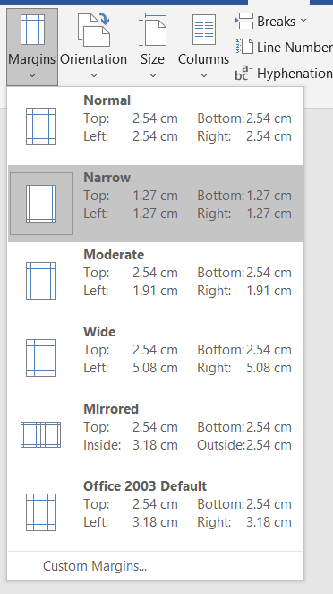

*2. Set a background for your table created.*

list of steps to add a background in Microsoft Excel document given below -

Step 1: Open a new or an existing Microsoft Excel document in which you want to add a background with the fill color tool.

Step 2: Press the Ctrl+A keys from the keyboard to select the whole Microsoft Excel document.

Step 3: At the top left corner of the Microsoft Excel document, click on the vertical arrow under the cell selection menu as shown below given screenshot.

Step 4: Now, click on the Home tab and click on the Fill color drop-down icon under the Font group. A color picker will appear on the document. Select the color that you want to apply as a background on your Excel document.

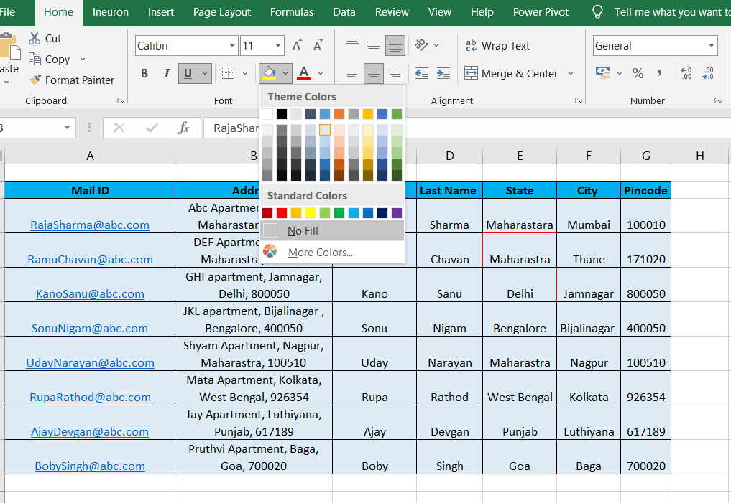

*3. What is freeze panes and why do we use freeze panes? Give examples.*

**freeze panes :**

Excel has a freeze pane feature to freeze the part of the Excel worksheet. It is used to freeze the row and column. When the Excel worksheet is large, freeze pane is a useful option to freeze the particular part of the worksheet and make the other part scrollable.

**use freeze panes :**

In Excel, users can use the Freeze Panes feature of Excel to freeze the row or column of the worksheet.

They can freeze panes to freeze the single or multiple rows/columns.

Rows and Columns keep visible when they are frozen.

*4. What are the diﬀerent features available within the Freeze Panes command?*

Excel enables three methods to freeze the pane.

1. Freeze Pane
2. Freeze Top Row
3. Freeze First Column

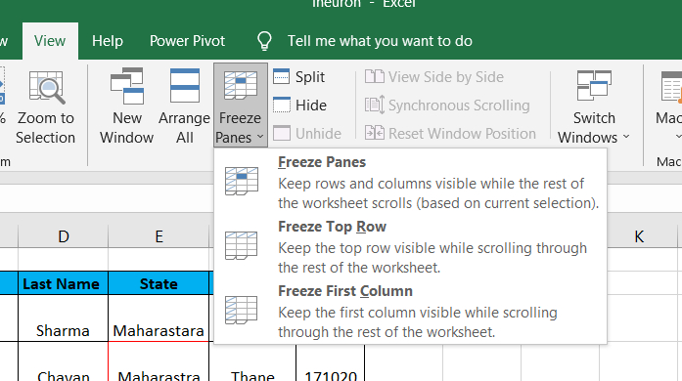

Freeze Pane : When we freeze a part of the Excel worksheet using this freeze pane option, it keeps the rows and columns visible, scrolling is available through rest of the worksheet. This one allows the user to freeze the worksheet wherever he/she want. It freezes both rows and columns of the worksheet.

Freeze Top Row : When we freeze the top row of our Excel worksheet using this freeze pane option, the first row of the Excel worksheet freezes and visible through the entire scrolling of the worksheet vertically.

Freeze First Column : When we freeze the first column of our Excel worksheet using this freeze pane option, the first column freezes at its place and is visible through the entire scrolling of the worksheet horizontally.

*5. Explain what the diﬀerent sheet options present in excel are and what they do?*

Based on requirements, an Excel workbook can have many sheets. The sheets are typically listed as tabs and are accessed from the bottom of the Excel window.

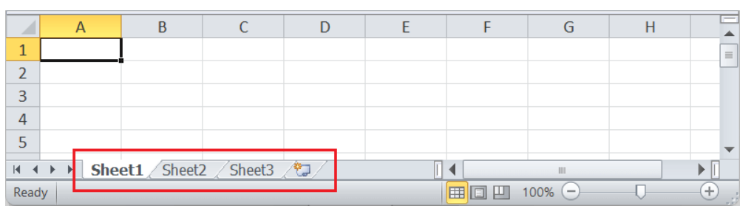

**Sheet Options in Excel**

In the above image, the default Excel sheets are present on the Sheet Toolbar. We can switch between the sheets by clicking on the sheet's name that we want to view. Also, there are many things or tasks that we can perform with Excel sheets. All the corresponding features of the sheet are accessed using the Sheet Options in Excel.

We can access various sheet options by using the following ways:

1. Ribbon Sheet Options
2. Right-click Sheet Options

**Ribbon Sheet Options**

Excel has all the basic and advanced options present on its ribbon. Likewise, some quick sheet options are also present on the Excel ribbon and can be accessed by going to Page Layout > Sheet Options. It mainly has four toggle options: two for Gridlines and two for Headings, and they can be turned on and off by selecting and deselecting the checkboxes.

Gridlines:

View: This option allows users to show/ hide gridlines within the active worksheet. Turning off this option removes the gridlines from the sheet and displays a blank Excel sheet.

Print: This option allows users to show/ hide gridlines on an Excel document that will be printed on paper.

Headings:

View: This option allows users to show/ hide headings within the active worksheet. Turning off this option removes the headings from the current sheet's headers and footers.

Print: This option allows users to show/ hide headings on an Excel document, which is to be printed on paper.

The above sheet options are worksheet-specific, and changes are only applied to the active worksheet. This means that we have to adjust these options again for the new worksheets and workbooks.

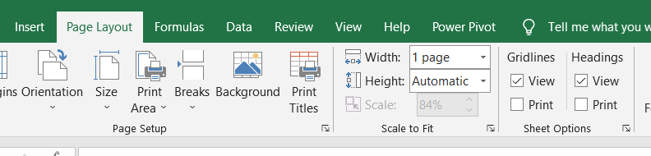

**Right-click Sheet Options**

In Excel, the right-click with mouse button usually displays the context menu for the selected element. When we press the right-click on any Sheet tabs, Excel displays a list of options relevant to Excel sheets. The list includes various sheet options. However, this list is usually called the 'worksheet menu'.

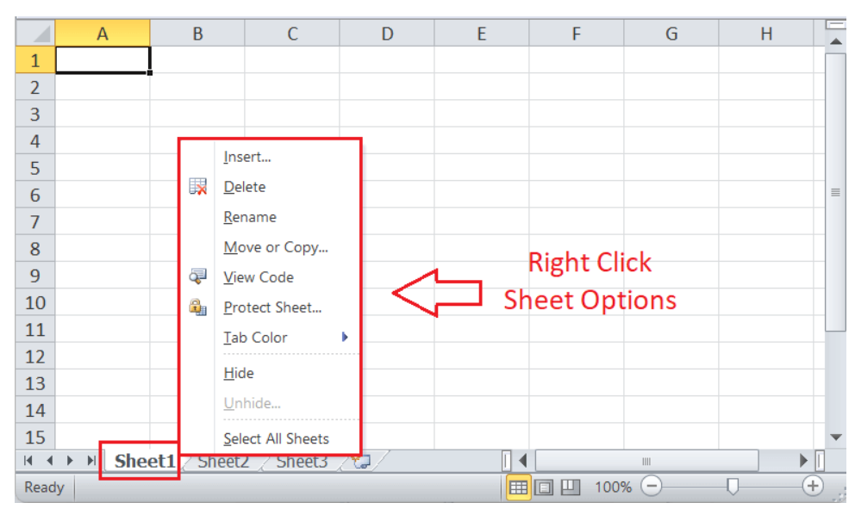

Insert

While working on Excel, we may sometimes need more sheets. For this, we need to go to the Sheet options by right-clicking the worksheet name on the sheet tab, then select Insert from the list. As soon as we click the Insert, the new blank worksheet will appear in the current workbook.

Delete

Excel also allows us to delete the undesired sheets from the workbooks. For instance, suppose that we only want to organize our data in a single sheet, then deleting the remaining sheets will give a professional and clean look to our workbook.

To delete any desired sheet from the workbook, we must first press the right-click on a specific sheet on the sheet tabs and then select the Delete option from the list of sheet options.

Rename

To rename the worksheet, we can use the Rename from the sheet options after right-clicking on the desired sheet name on the sheet tab. After that, we need to enter the desired name for the specific worksheet and click the Enter key. The worksheet will be renamed instantly.

Move or Copy

When we need to duplicate the data from one sheet to another in Excel, we can use the Move and Copy option from the right-click sheet options list. We must first right-click on the sheet that we wish to copy and then select the 'Move and Copy' option.

View Code

We can launch VB (Visual Basic) Editor by going to any sheet tab, right-clicking ad choosing the option 'View Code'. However, this option is rarely used to launch VB Editor. If we launch VB Editor using the 'View Code' option on any sheet tab, Excel will open a code window for that specific sheet. Therefore, this option to launch VB Editor is mainly useful when writing code that will work only for a particular sheet. For example, creating worksheet events.

Protect Sheet

If we protect any desired sheet within the workbook, Excel restricts users from editing or deleting the specific sheet. To protect any particular sheet in an Excel workbook, we need to right-click on the desired sheet and select the 'Protect Sheet' option.

Tab Color

The sheet tabs can be colored with the desired color. We can change the default sheet tab's color by using this option. Using any specific color on any particular sheet's tab helps us easily navigate to that sheet among various worksheets. To change the color of the sheet's tab, we need to select the Tab Color option from the list that we get after right-clicking on the sheet's tab. Next, we must click on the desired color, and it will be immediately applied to the selected sheet tab.

Hide

By default, Excel displays all the sheets of the workbook son the sheet tab. We can view or access any sheet from the sheet tabs. However, there may be cases when we don't want to show any specific sheet to others, but it has important data in context to other sheets. It is good to hide the specific sheet in such a case, and there will be no effect on the referencing data.

Unhide

Like we hide the sheet in an Excel workbook, we can unhide the sheet in the same way. We need to select the Unhide option from the list of right-click sheet options, and the corresponding sheet will again be visible. If there are multiple hidden sheets within the workbook, Excel displays a list of all the hidden sheets and asks us to choose desired sheets that we want to unhide.

Select All Sheets

If we want to select all the workbook sheets at once, we can click on the 'Select All Sheets' option from the list. Once all the sheets are selected, we can perform some specific tasks on all the selected sheets at once.